**User Documentation**

## Start “Alien Banjo Attackers from Space”

To start the game simply open the game package and double click the icon named “Alien Banjo Attackers”.



The game will start and the Attract Mode screen will be shown as you can see in the example below.

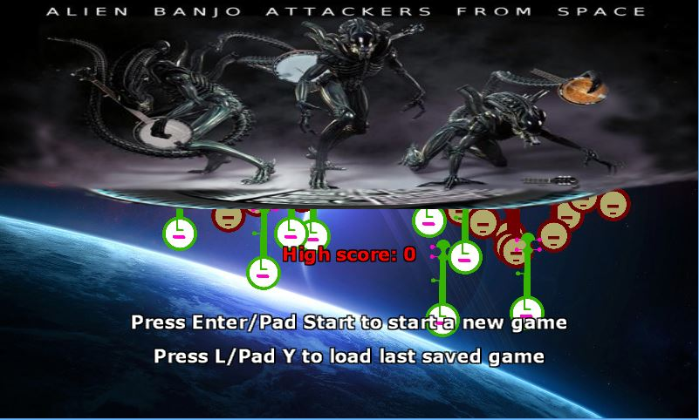

# Start playing

To start playing the game simply follow the instructions on the screen.

Either a Windows keyboard or an Xbox 360 Controller can be used to play.

To start a new game press **Enter** (keyboard) or **Start** (controller).

To load the last saved game press **L** (keyboard) or **Y** (Controller).

In this action packed space shooter you must control the “Battleship Accordion” in its fight to save the planet from an attack of deadly space banjos.

You must shoot the banjos using musical notes and prevent them reaching the bottom of the screen.

There are three types of killer banjo alien, if any of them touches your battleship, you lose a life.

After the player loses three lives the game is over.

# Controlling the battleship

To move your battleship you can use the **Arrow Keys** (keyboard) or the **D Pad** directional buttons (Controller).

To fire your deadly notes you can use the **Spacebar** (keyboard) or **A** (Controller).

# Enemy types

There are three types of banjo in the game:

* **Plain Banjo**: it moves from left to right. When it reaches the edge of the screen it drops down and then moves back. If it reaches the bottom of the screen the game is over. It takes one hit to destroy and is worth **10** points.



* **Hunter Banjo**: it will behave like a plain banjo for five seconds and will then move towards the player. If it reaches the bottom of the screen the game is over.

It takes one hit to destroy and is worth **20** points.

* **Deadly Strummer**: This moves towards the player as soon as it appears. It moves faster than the Hunter banjo.

It takes two hits to destroy and is worth **50** points.

# Saving the game

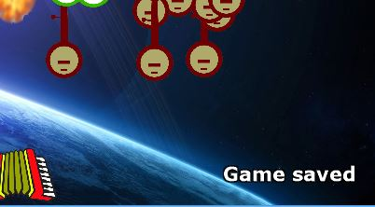

While playing you can press **S** (keyboard) or **X** (Controller) at any time to save your current game.

A message will appear for few seconds if the game saved successfully.

# Loading the game

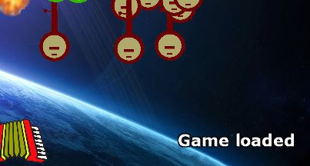

In the Attract Mode screen you can press **L** (keyboard) or

**Y** (Controller) to load your last saved game.

A message will appear for few seconds if the game loaded successfully and the game will continue from that point.

# Game Over

When you have lost all of the three lives or any alien made its way to the bottom of the screen (even if you still have lives), the game will be over.

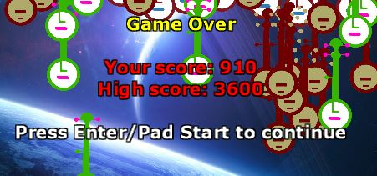

# High Score

In each session a high score will be shown both in the Game Over and Attract Mode screens.

The high score will be lost after closing the game.

Beat that score to be the very best. Good luck and have fun!

# Exit the game

To exit the game simply press **ESC** (keyboard) or **Back** (Controller).